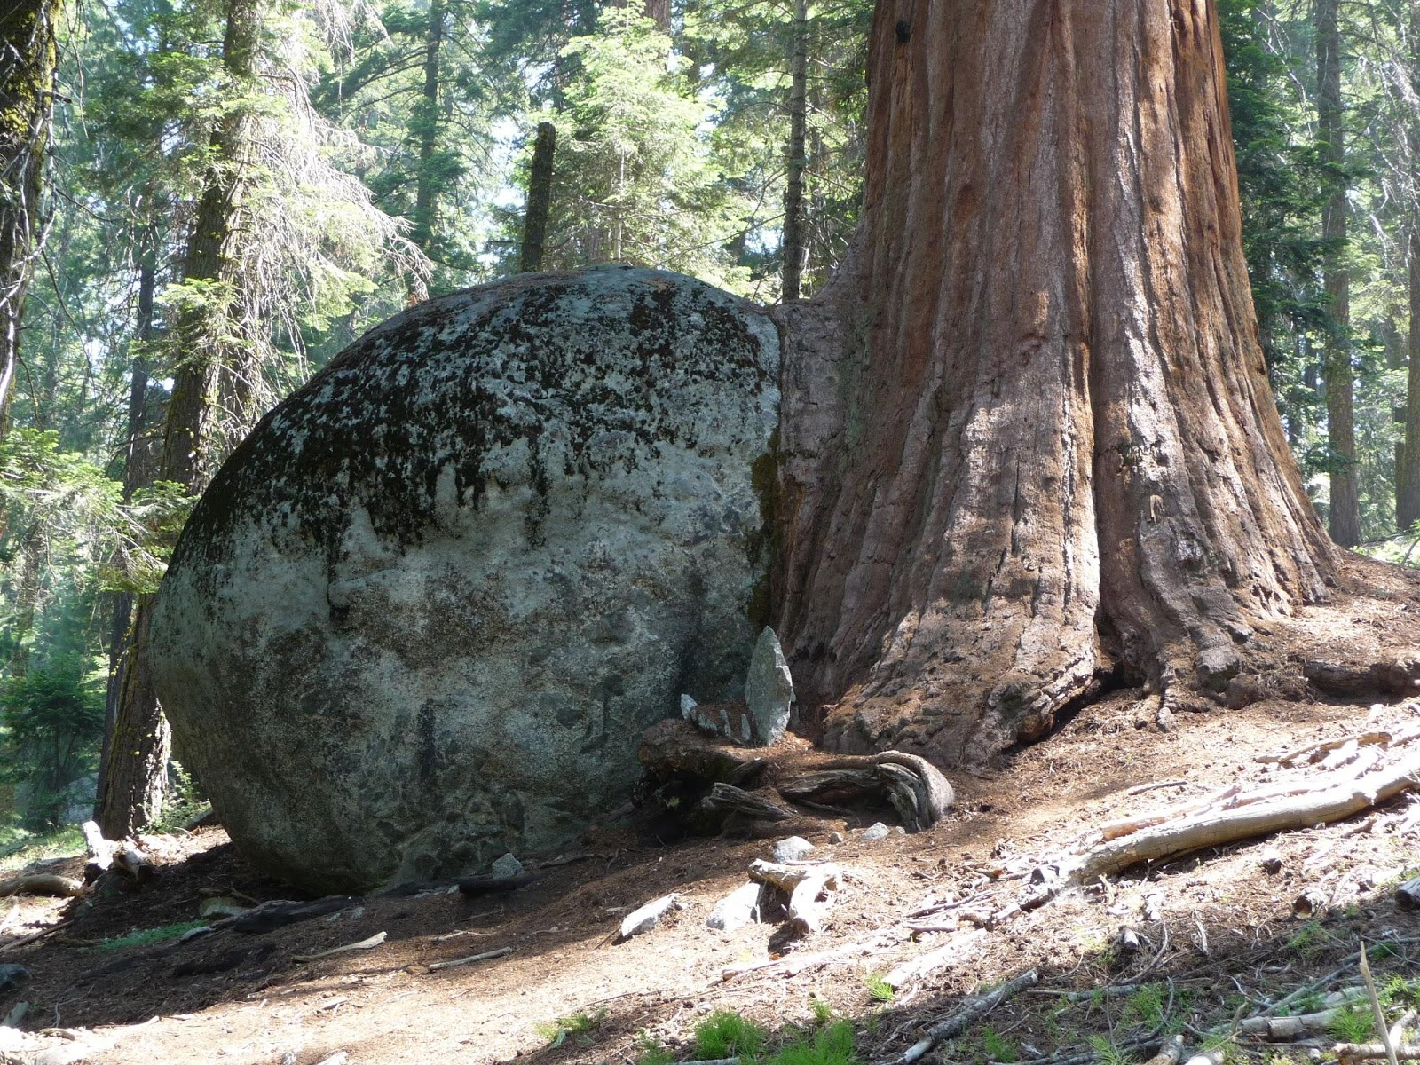

The Practice: Application

Please complete application (BELOW) with the answers to the following questions. We will contact you within 24 hours to schedule interview. Registration is secured once application process is complete & deposit has been received. All information received is private & confidential.

Please email completed application to BOTH EMAILS: info@evenflowyoga.com and ohanarisingyoga@gmail.com

- What is your relationship with yoga?

- (Please answer question #2 only if you are applying for the 500 Hour Advanced Training) Where did you receive your 200 hour certification?

- How do you apply your yoga to you your life and/ or your teaching presently?

- What does The Journey of the Teacher mean to you?

- What is inspiring you to do this training? Do you have a specific goal in mind?

- List Yoga history, experience, styles practiced and previous training:

- Yoga or related teaching experience:

- Influential teachers, teachings, books you have encountered:

- Please enter your level of interest for the following topics (L=low, M=med, H=high): Philosophy___ Meditation___ Pranayama___ Teaching principles___ Diet and nutrition___ Career____ Asana____

- Please list or comment on any other areas of special interest to you:

- Special skills, hobbies, sports, occupation, etc.:

- Any injuries or illnesses:

- Are there any health concerns we should be aware of in order to help support you in this training?​

